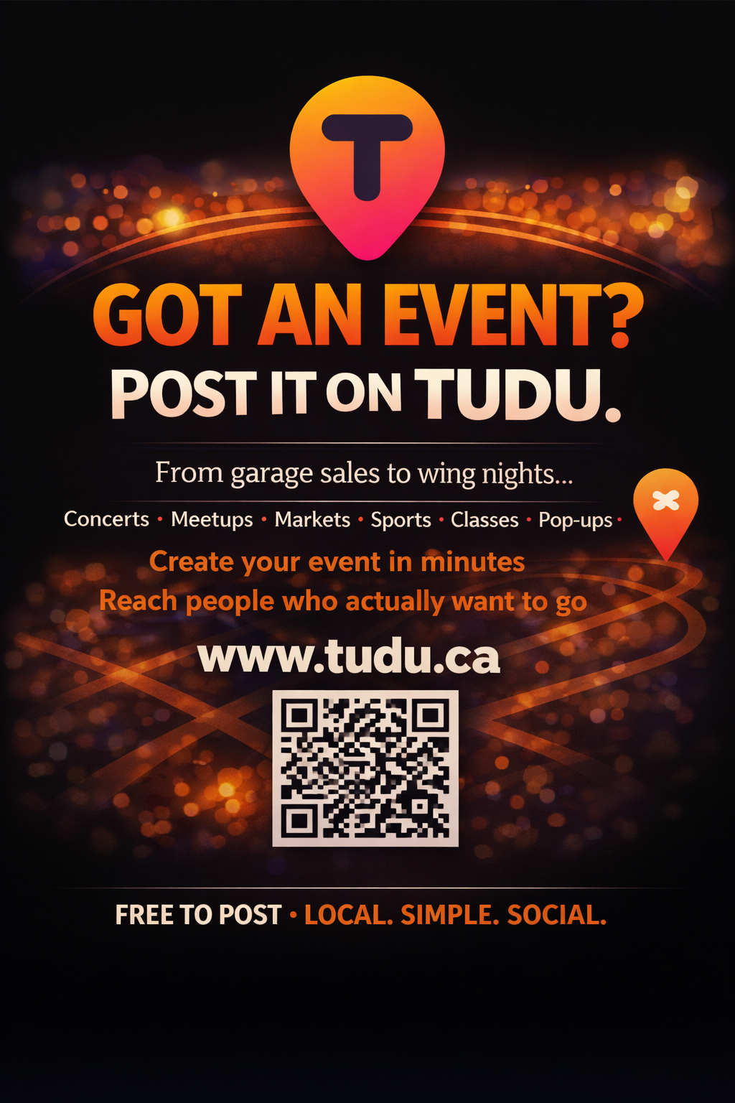
We built TUDU because we wanted a better way to find things to do — and a better way to share what’s happening locally.
Not ads.
Not noise.
Just real events and real people.
From garage sales and wing nights to concerts, classes, markets, and meetups — if you’ve got something going on, we’d love for you to post it. And if you’re looking for something to do, we’d love to have you join us.
This is TUDU.
Free to post. Built for locals.
🔗 www.tudu.ca
📍 Come see what’s happening near you.
— The TUDU Team



Want to escape the chaos of social media — and still know what’s going on?
We did too.
That’s why we built TUDU.
TUDU is a quieter way to discover local events.
No endless scrolling. No algorithms fighting you.
Just real things happening nearby — shared by real people.
If you’re hosting something, post it.
If you’re looking for something to do, join us
FREE TO POST • LOCAL • SIMPLE • SOCIAL
www.tudu.ca
— The TUDU Team

Post 5
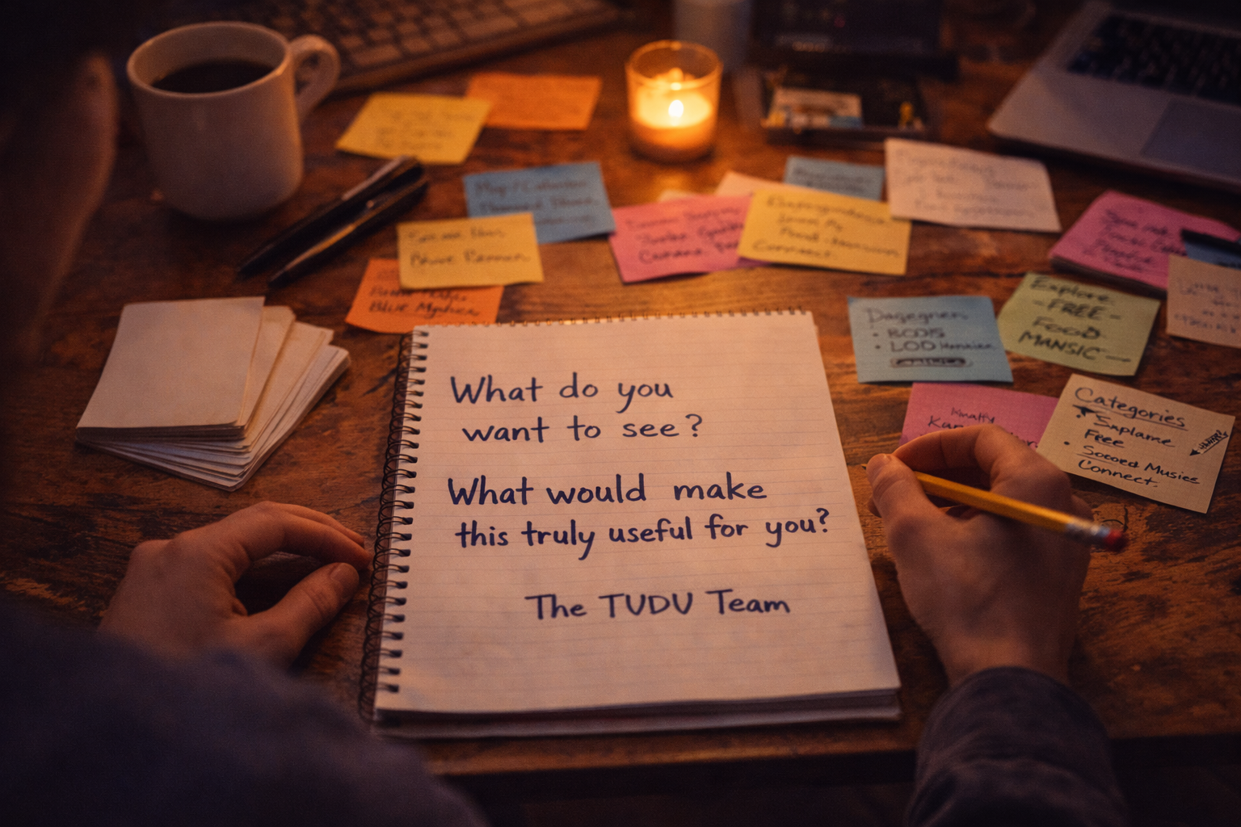

TUDU isn’t finished — and that’s intentional.
We’re building this with real people and real communities in mind.
What would make this useful for you?
What do you wish was easier to find locally?
We’re listening.
— The TUDU Team

